
7320 W. Agatite Ave.
Norridge, IL 60706
Tel 773-588-8890 Fax 773-478-4584
TOLL FREE 1-800-626-6556
E-MAIL: sales@lexcocable.com
www.lexcocable.com

Thank you for your interest in Lexco’s Clevises.

Please inform your Lexco sales representative on the custom specifications listed bellow in order to proceed with a quote.

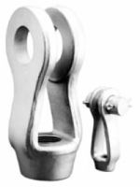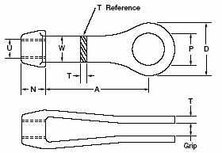

CUSTOM CLEVIS DIMENSIONS:

1) TAP DIA. & THREAD PATTERN (U) =

2) GRIP (PLATE THICKNESS +1/8") =

3) PIN DIA. (P) =

CLEVIS MATERIAL:
- CARBON STEEL
  - SELF COLORED, GALVANIZED, PLATED
OR
- STAINLESS STEEL
  - UNTREATED

